Image Classification with Deep Models, CIFAR-100 Image Classification using DNN
Student Name:Christian Browning
Student ID: 201690097

Introduction
The problem I will be investigating is image classification specifically for the CIFAR-100 dataset. The objective is to take the baseline model of ResNet and see how hyper parameter tuning, synthetic data generation and advanced additions such as attenuation models can increase the performance of this baseline model. This report will include the iterative design, experimentation, and analysis of the ResNet model for CIFAR-100 classification.
The first bit of iterative design completed will be hyperparameter tuning. This is important before further developing the baseline to ensure that the baseline is starting at a capable position. The goal will be to explore the best settings of batch size, learning rate, c_hidden, num_blocks, etc. before moving onto real design changes.
The report will go further and test the addition of attention systems in both global and channel based systems. After the report will test the use of Conditional Generative Adversarial Network (cGAN) for generating realistic CIFAR-100 data and using the discriminator systems as feature extraction.

Methodology

Dataset: Overview of CIFAR-100.
The CIFAR-100 dataset is 60000 32x32 colour images in 100 classes, with 600 images per class (Krizhevsky, A. and Hinton, G. (2009)). It’s a simple image and feature recognition dataset that is used as a benchmark for systems that focus on these points. The dataset is easy to access and open to use.

Baseline Model - ResNet:
I chose ResNet for its wide use and its ability to handle vanishing gradient issues as ResNet was specifically designed to make the training of deep networks more stable and easier. Furthermore, I chose this model specifically for the vanishing gradient problem as I wanted to investigate potentially using it in my personal dissertation as I am investigating synthetic data generation as a part of it where vanishing gradients are a huge issue.
The vanishing gradient problem especially effects deep learning networks as its harder to regulate the gradients within deep networks. During training some gradients in deep networks become smaller and smaller tending towards zero, generally it causes layers closer to the input layer to train slower or to tend towards 0 making them useless or actively detrimental to training (Pascanu, R., Mikolov, T. and Bengio, Y. (2013)).
Resnet attempts to mitigate the issue of vanishing gradients with residual (skip) connections (He, K., Zhang, X., Ren, S. and Sun, J. (2016)). The residual connections mean that gradients are refed through the network repeatedly so that these gradients are not lost leading to more stability during training. In simple terms information from earlier layer are added to later layers to ensure that the information isn’t lost during training, essentially information from earlier models skips over later layer. The skipping over of later layers means that the process of back propagation is more stable by creating more direct gradient updates meaning they continue to learn through long training times.
The effectiveness of ResNet at image classification has been proven oftain such as in the paper “IX-ResNet: fragmented multi-scale feature fusion for image classification” (Xue, T. and Hong, Y. (2021)).
As stated, I have a personal research interest in ResNet for my own dissertation as I am finding vanishing gradients a constant hurdle in my work. My dissertation is in sequential data so it’s an even bigger issue as the networks have to be continuously and increasingly deep. Through this project and picking of Resnet I hope to design solid ResNet knowledge as well as a frameowkr for developing these systems for my own purposes.

Simple Hyperparameter exploration:
The report will first complete basic hyperparameter exploration to find, for the baseline ResNet model what are the best settings. The hyper parameters tested will be as follows:
Parameter | Values Tested | Description
Num Blocks | [3, 3, 3], [2, 2, 2] | In the ResNet model the number of blocks in each stage
Channels | [16, 32, 64], [32, 64, 128] | The number of feature maps used at each stage
Batch Size | 32, 64 | Number of samples per training batch.
Learning Rate | 0.01, 0.001 | “Step size” – gradient change at each learning event
Momentum | 0.9 | Stabilization of learning

Testing process
First all the hyperparameters were explored until a basic plateau was reached and the training was stopped, this will take 25 epochs. Then further continued testing will occur on the highest preforming models to see if this plateau is consistent for a further 10 epochs. If it isn’t then taking the further highest preforming and test it for a further 10. If at any point a global plateau is discovered, then move on to more complex model design. The global plateau is to determine when the baseline Resnet can no longer learn so acts as our baseline number of epochs that our complex models will also train until.

Implementation Details:
The hyper parameters will be tested using a basic hyper parameter exploration framework I made for my dissertation heavily inspired by the SK-learn grid-based exploration. I designed it as an overall framework that I can use for general hyper parameter exploration for any input model and hyper parameter. For this project it is much simpler as I am just testing one type of model. It completes a grid search of all possible combinations of hyperparamiters.
The program stores all the data genorated iteratively making it robust to memory leaking and other causes of crashes. The results are stored in a folder “result+Datetime “so no data is overwritten. Within the folder each model configuration is stored in their own folder containing tensorboard data, individual epoch data and the best model generated. The system also maintains a “all hyperparameter” csv that holds the test data for each configuration for easy comparison.

Complex Resnet Designs
The complex designs the report has chosen to be investigated are revamped ResNet, a Residual Attention Block (Wang F, Jiang M, Qian C, et al.) and a Channel Attenuation Layer which works similarly to the 'Squeeze-and-Excitation' (SE) block (Hu, J., Shen, L., Albanie, S., Sun, G. and Wu, E. (2017)). These were chosen because they are easy and understandable additions to a already effective baseline.

Synthetic data generation: Conditional Generative Adversarial Network (cGAN)
As part of the novelty of the design I have decided to also investigate cGANS for the dataset. This will include iterative experminettation of: baseline cGANs using the dataset, Skip Connection cGANs, full ResNet cGANs and Multi Objective Generators. The cGAN system will improve the overall performance of the ResNet system in several ways such as using the data created by the cGAN to Reduce overfitting, increase dataset size and introduce more diversity for training. Moreover, the pre trained GAN’s Discriminator could be used as an advanced Feature Extractor for the Resnet system. Finally, the Generator system could be used as potential Adversarial Training tool to improve robustness and stability.
I choose cGAN over other systems like cVAE’s as I wanted to explore advanced uses of the Discriminator module of the system as well as GAN’s producing generally better images in my personal research experience.

Testing process
First the basic cGAN will be tested as a baseline and its results stored. Then advanced models will be trained and their results compared. As cGAN’s are 2 separate adversarial systems then different combinations of types can be tested to find improvements and best working cmbinations. These tests are defined as follows:
Test Number | Generator | Discriminator
1 | ConditionalGenerator | ConditionalDiscriminator
2 | SkipConnectionGenerator | SkipConnectionDiscriminator
3 | ResNetGenerator | ResNetDiscriminator
4 | ConditionalGenerator | SkipConnectionDiscriminator
5 | SkipConnectionGenerator | ResNetDiscriminator
6 | ResNetGenerator | ConditionalDiscriminator

Experiments and Results
- Provide performance metrics (accuracy, loss, confusion matrix).

Test Baseline
First the report will test and show the results of the baseline implementation given in Lab 07. The baseline only goes to 10 epochs which is unfair as the first test will be to 25 epochs however the report wants to show development in the testing strategy. The general results are displayed bellow:
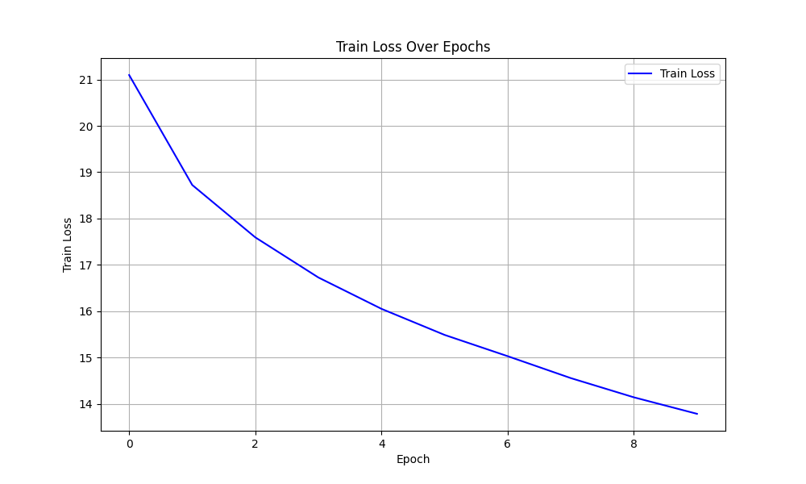
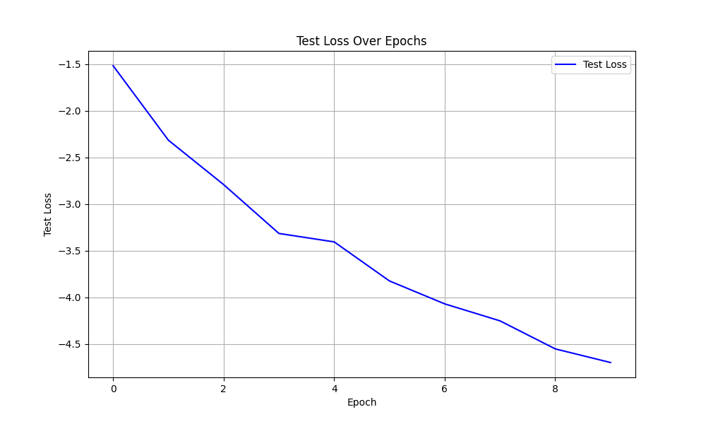
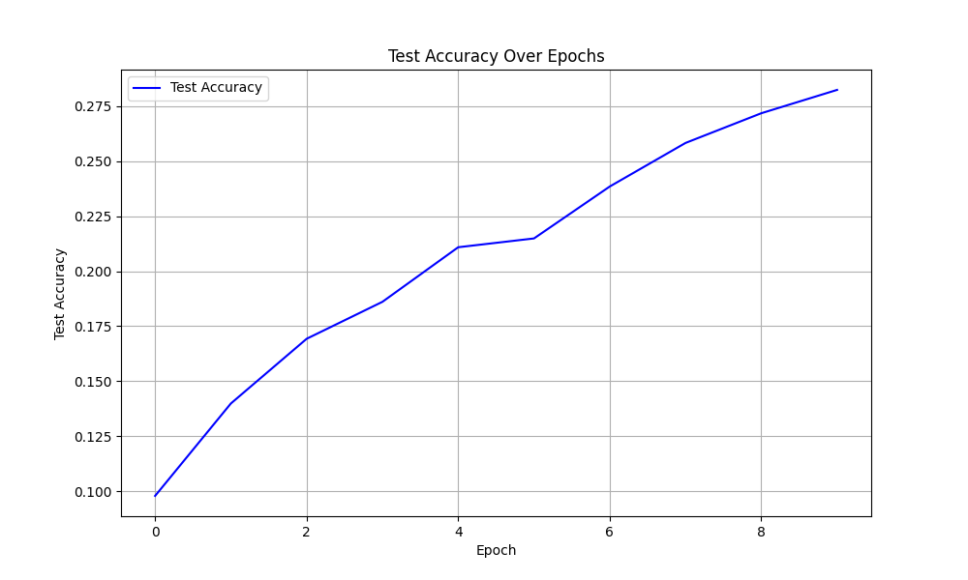
From these results it was observed that the accuracy keeps increasing and Losses steadily and evenly decreasing at a fast rate so the final result of 0.2824 does not represent a plateau in the results. Because of this, further and increased epoch testing was determined to be needed.

Hyperparameter Exploration

Round 1
The following hyper parameters were tested for 25 epochs. For the hyperparameter code design see Hyperparamater_round1.py
Parameter | Values Tested | Description
Num Blocks | [3, 3, 3], [2, 2, 2] | In the ResNet model the number of blocks in each stage
Channels | [16, 32, 64], [32, 64, 128] | The number of feature maps used at each stage
Batch Size | 32, 64 | Number of samples per training batch.
Learning Rate | 0.01, 0.001 | “Step size” – gradient change at each learning event
For the entire results table please see Appendix section 6.1.1. The general results are displayed in graphs bellow: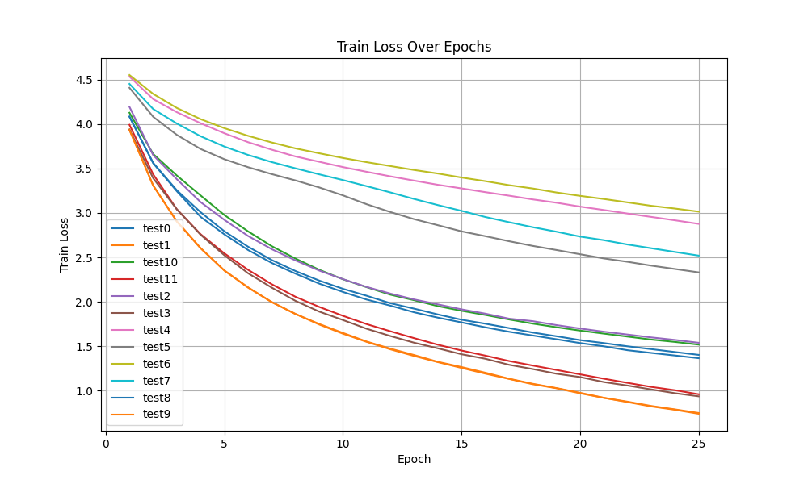
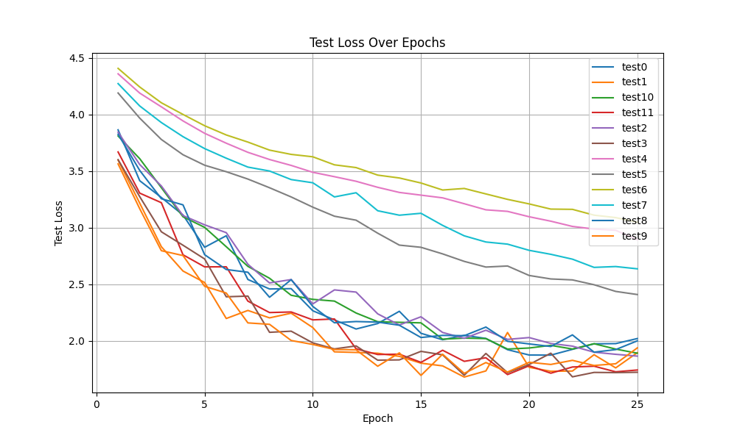
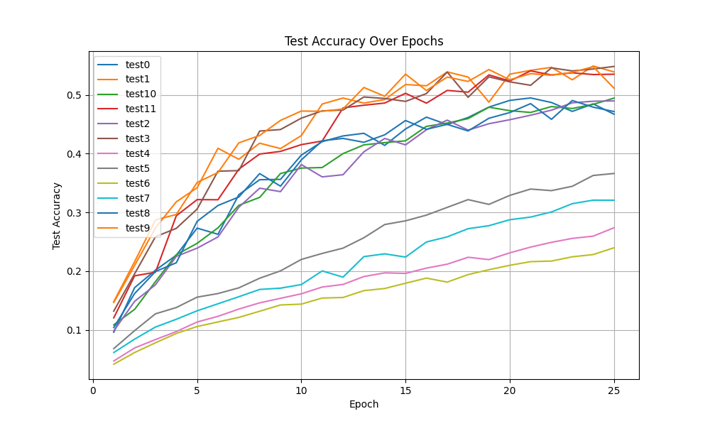
Figure 6 Test Accuracy Curve
From these results we see that at least 4 combinations can be completely disregarded them being test 6, 4, 7 and 5 with generally bad scores. From a detailed analysis of the results the following general conclusions can be made:
- Batch size does not have a significant impact between 32 and 64.
- Learning rate of 0.01 consistently out preforms 0.001.
- Number of blocks does not have a significant impact on results within the range of [3,3,3] and [2,2,2].
- Number of Hidden Channels does matter with [32, 64, 128] consistently out preforming [16, 32, 64] in every case – but not by much.
Further general analysis shows that the results mostly stabilised and plateaued at around 20+ epochs ranging from 21- 25 being the best model. Because of this, the report decided to go further and test continue to test and train the models from 25->35 to see if this plateau continued in a hyper parameter Round 2.
To decrease the amount of time needed to test the plateau theory the top 5 configurations were chosen 0, 1, 2, 8 and 10. The tests were chosen because they had best epochs either close to or equal to 25 and they had some variety of hyper parameters that hadn’t been fully decided yet such as [3,3,3] and [2,2,2] or [16, 32, 64] and [32, 64, 128].
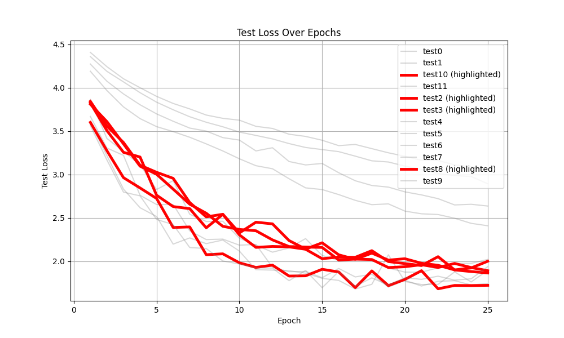

Round 2
In this second round the configurations of 0, 1, 2, 8 and 10 were tested. These configurations are contained within the following table.
Config number | Batch size | Learning rate | Num Blocks | Channels
0 | 32 | 0.01 | [3,3,3] | [16, 32, 64]
1 | 32 | 0.01 | [3,3,3] | [32,64, 128]
2 | 32 | 0.01 | [2,2,2] | [16,32,64]
8 | 64 | 0.01 | [3,3,3] | [16,32,64]
10 | 64 | 0.01 | [2,2,2] | [16,32,64]

These configurations were tested for a further 10 epochs giving the following results. The results were unclear and hard to interpret on their own so the report decided to plot it with the old data to give context.
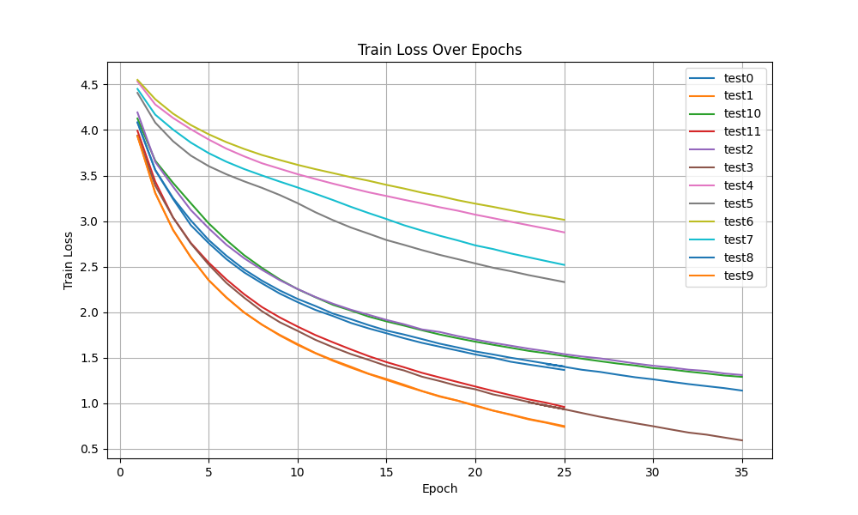
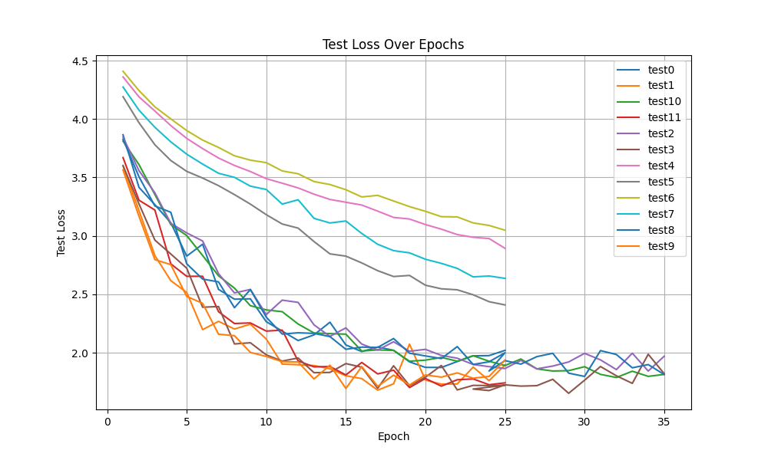
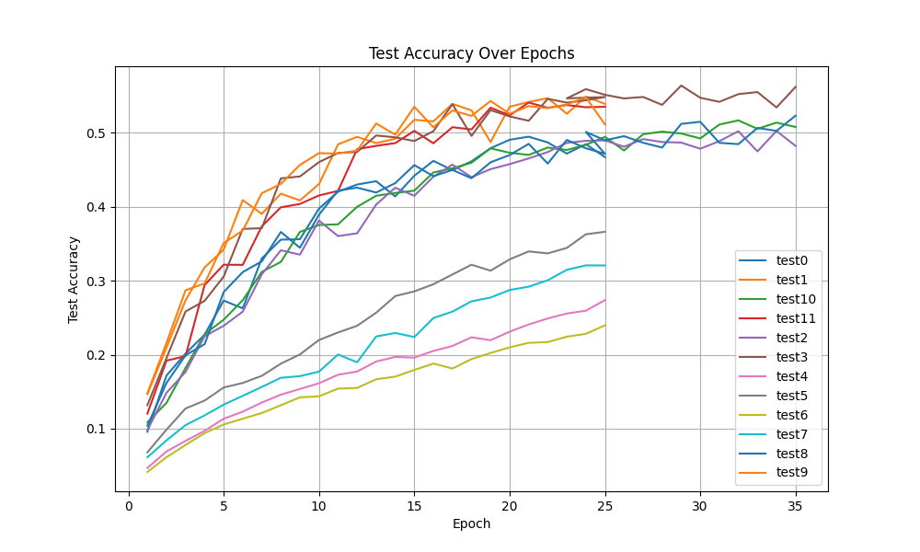
The report concluded from these results is that the plateau continued meaning that roughly 0.55 accuracy is the best that the baseline design can be optimized to achieve. From analysing which of the continued models did best the highest achieving hyperparameter configuration is the following:
- Batch Size: 32
- Learning Rate: 0.01
- Momentum: 0.9
- Blocks: [3, 3, 3]
- Hidden Channels: [32, 64, 128]

Structure Exploration:
The report continued and tested several different designs and structures for ResNet using these found high preforming hyper parameters. The structures chosen are a revamped ResNet, a Residual Attention Block (Wang F, Jiang M, Qian C, et al.) and a Channel Attenuation Layer which works similarly to the 'Squeeze-and-Excitation' (SE) block (Hu, J., Shen, L., Albanie, S., Sun, G. and Wu, E. (2017)).
These structures should theoretically do better than the simple resnet block as the attention should allow them to focus and learn the important aspects of the photos. They were tested using a similar system to the hyper parameter search system.
The models were tested for 50 epochs but had an early stopping system based on the test loss that had a patience of 10. I did this because I noticed that in the later epochs of the continued test the test loss trended to increasing at the end of 35 so decided to implement a simple patience system.
Bellow are the results – for the full table see appendix:

Results of structure exploration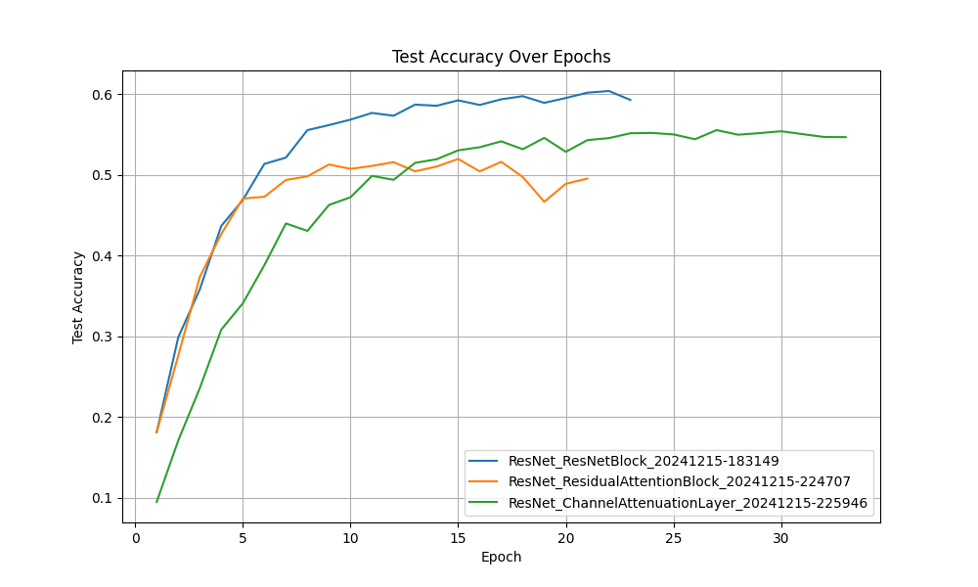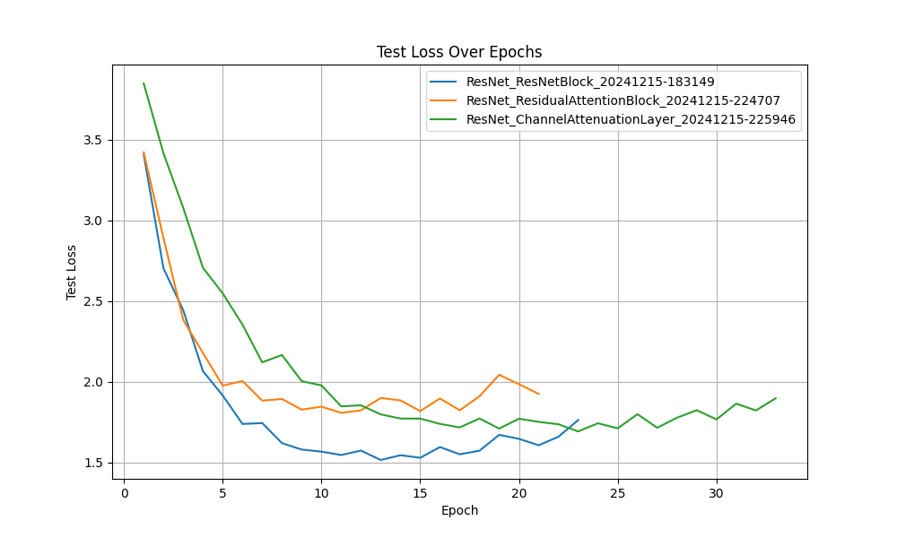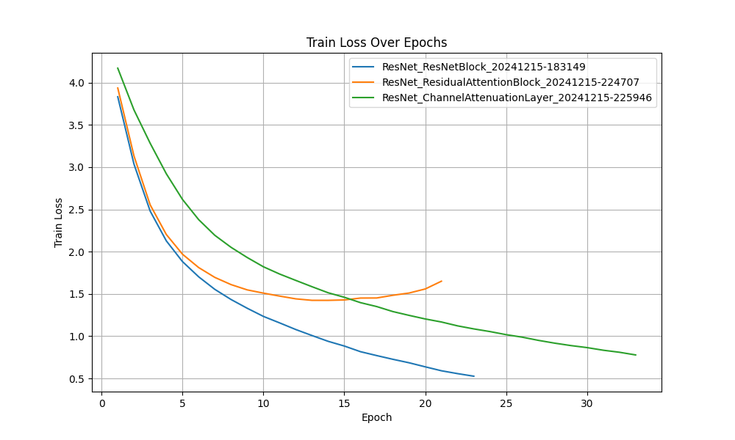
These results are interesting as the revampted Block did comparable to the attention systems while being simpler which is surprising, However further hyperparameter testing with these attention systems may be needed for true comparison. The report also believes that the seed must have been especially lucky as the ResNet model achieved a 0.57 test accuracy at epoch 13 which is the highest achieved so far.

Further modifications
Further modifications were made to decrease the clear overfitting that is seen in the later epochs, this included increasing normalisation. Bellow are the results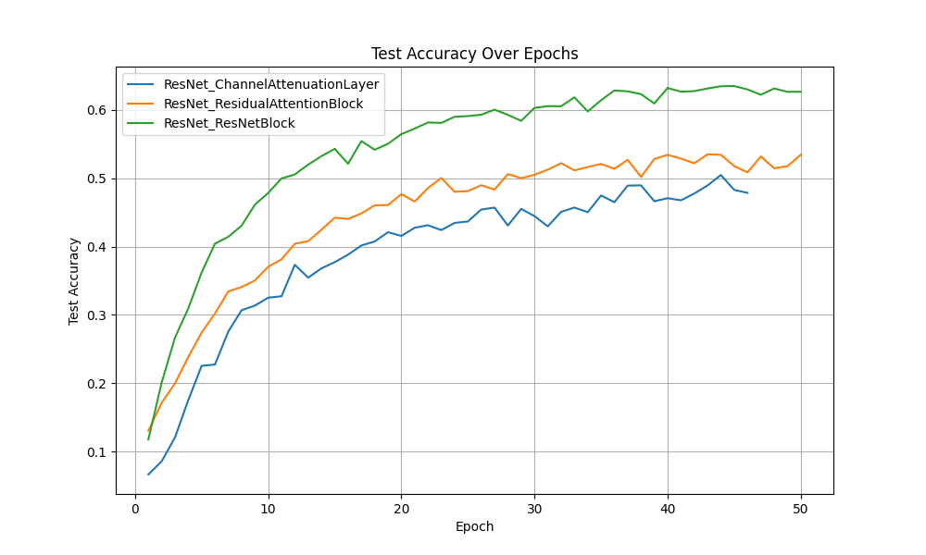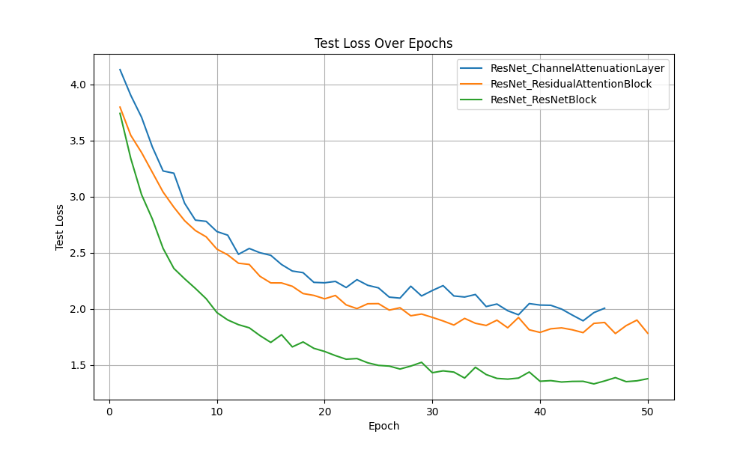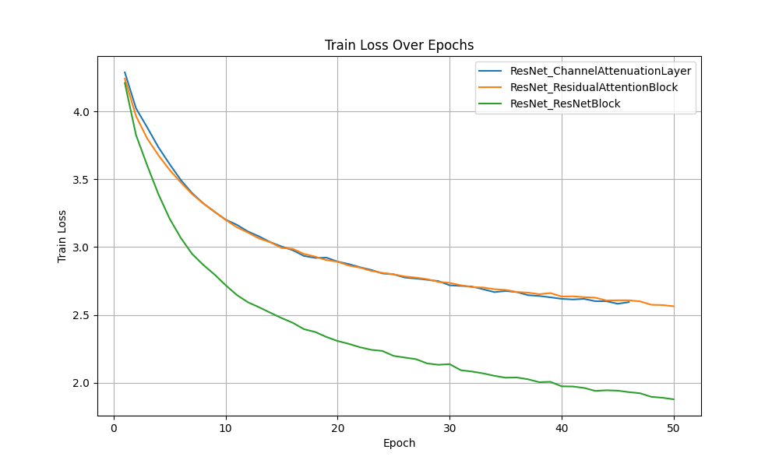
From these results the report has found that the advanced ResNet block outperformed the more complex attention systems. Which is interesting and says something about best practices when handling low resolution and low complexity data.

GAN Design
The report went further and reaserched GAN’s and their potential use within image classification and ResNet systems. Frist a basic GAN was used then several types of GAN inspired by ResNet structures were designed and implemented. The report spent a lot of time Investigating how to systematically analyse GAN’s through combined loss metrics, the system is adversarial, so combined loss is Generator loss + Discriminator loss.
The report tested Several GAN structures such as: Basic Conditional GANs; Skip Connection Generator inspired by the working of skip paths within ResNets (Akram, A. and Khan, N. (2021)); ResNet Generators which have a ResNet Block inside them Wang M, Li H, Li F (2017).
The first test the report completed was a structure analysis grid search that worked similarly to the hyper parameter search but instead of systematically using hyper parameters it systematically combined the 2 ends of a GAN together (generator and discriminator) from the 3 systems to find which combo worked best.

GAN Combination testing result
The report tested every possible combination of Basic/Skip/Resnet, this gave the following results, for a example table see appendix:
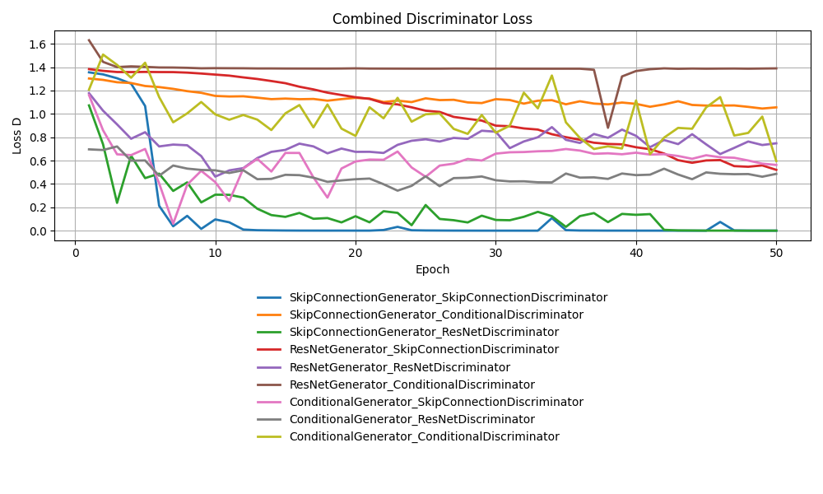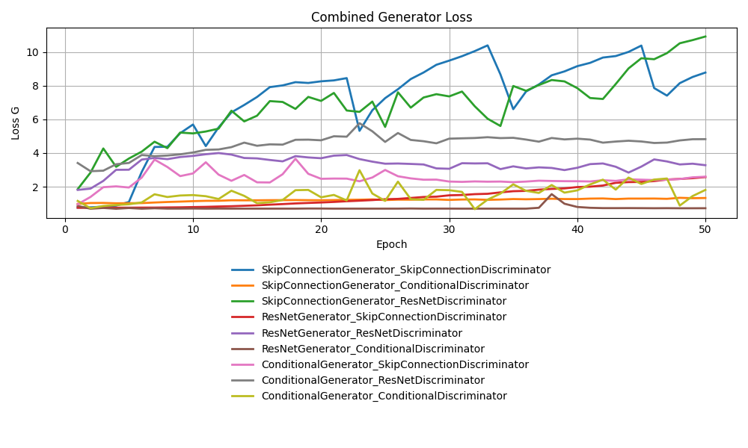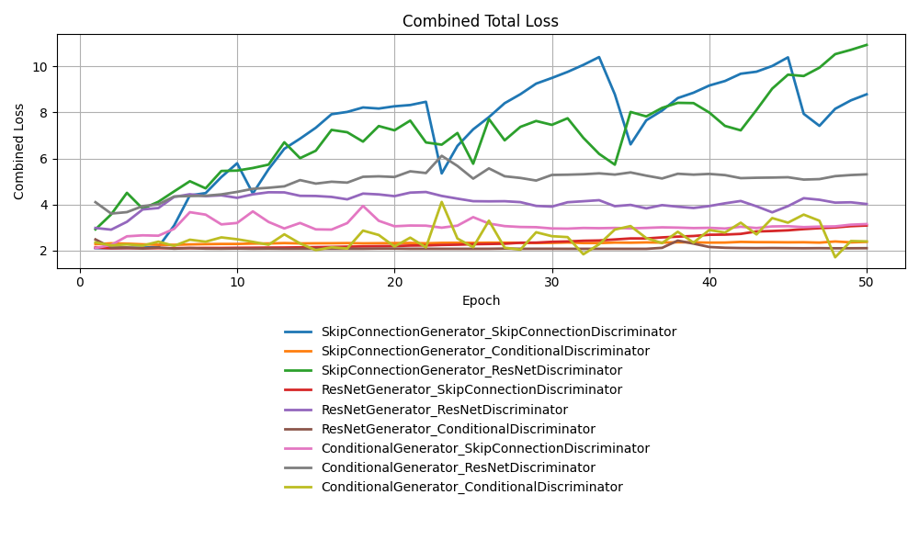
The similarity between the combined loss and Generator loss is because generator loss dominates the combined loss due to differences in scale. From these results clearly poor preforming structures were identified.

Further development and hyper parameter testing
One of the structures identified to be worth further testing was the skip generator which had the worst, second worst and best results so it continued to be developed. The Skip Connection Generator was fixed by changing how it handled the skip data, concatenation instead of basic modification, and was further developed by adding normalisation and channel matching to the output so it would be more specific and accurate. Another development was the idea of upscaling, this was to take the low-resolution data of the dataset and upscale it to a larger more easy to understand, but blurry, format. The upscaling was found to be effective and was added to almost all models. From preliminary testing the skip systems were found to stabilise and outperformed all other models tested. This was effective so Hyperparameter testing was completed on this model.
Below are the results:
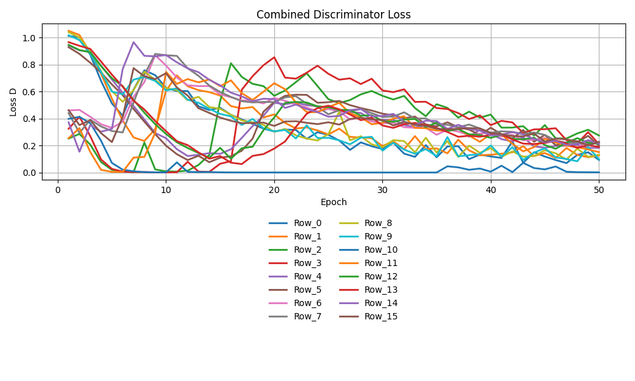
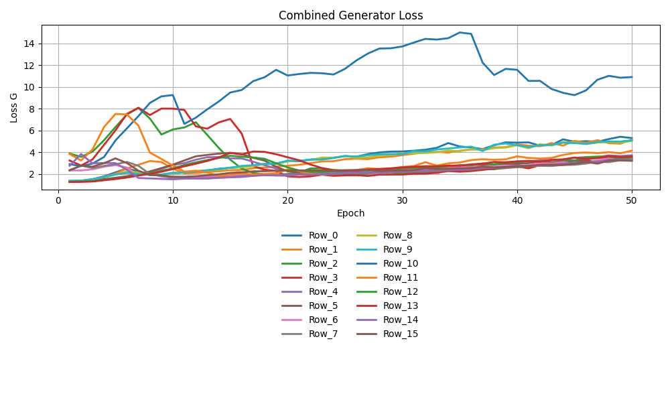
From these best settings were discovered and the full GAN system was complete.

Testin of final GAN
The skip GAN system was trained further for 150 epochs to produce synthetic data.
The resulting synthetic data is below:
Class | Fake | Real
COW | 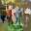 | 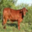
CRAB | 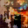 | 
BOWL |  | 
BUTTERFLY | 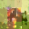 | 
FOREST | 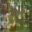 | 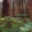

These results are encouraging as they appear to start pulling correct understanding of the underlying class’s features, the forest is the most encouraging. The report realised its expectations had to be tempered as realistic and sharp images are incredibly challenging to achieve from low resolution data. 32x32 is simply not enough actual data to learn “figuring” or other complex high level synthetic data achievements.

Implementation of GAN into ResNet
The Report decided to start implementing a ResNet with GAN feature extractors as the system created was found to be satisfactory. The system works by changing the discriminators output from a binary real / fake to the final feature weight before the binary decision, as discriminators have to analyse the data effectively to determine real or fake then their data processing units must therefore be effective (Chow KVC, O'Leary C, Paxton-Hall F, Lambie D, O'Byrne K)
This was done by first loading the discriminator model into a premade class, freezing the weights and placing that class as a processing layer within a larger class. Several types of larger class were tested, inspired by the types of ResNet classes tested. The classes being: a complex feature model which had several ResNet layers, a channel attention ResNet system, a simpler ResNet block system taken right from the high preforming system previously made with 1 Resnet layer and finally a Simple one attention block that did one attention layer in its operation.
The results are displayed bellow, a example of the results table can be seen in the appendix table: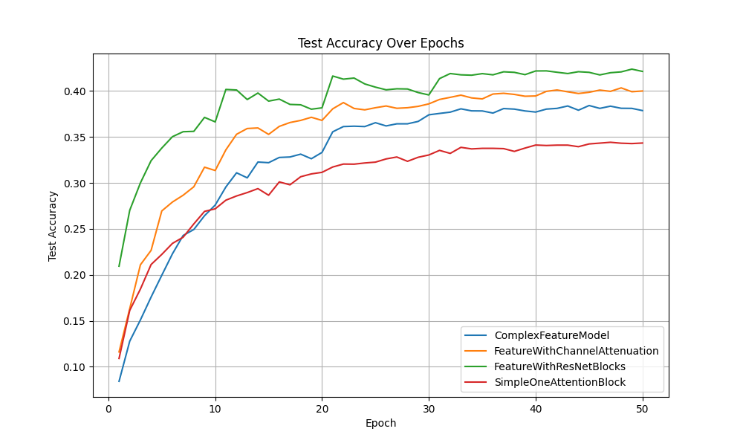
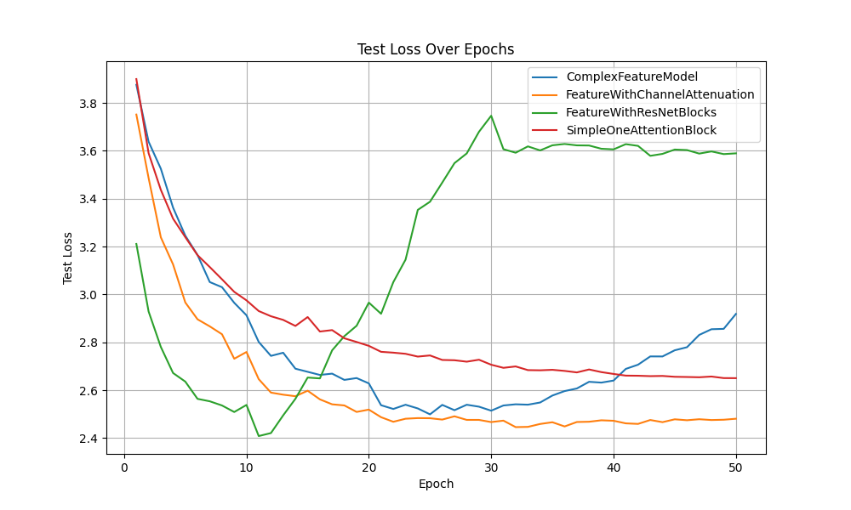
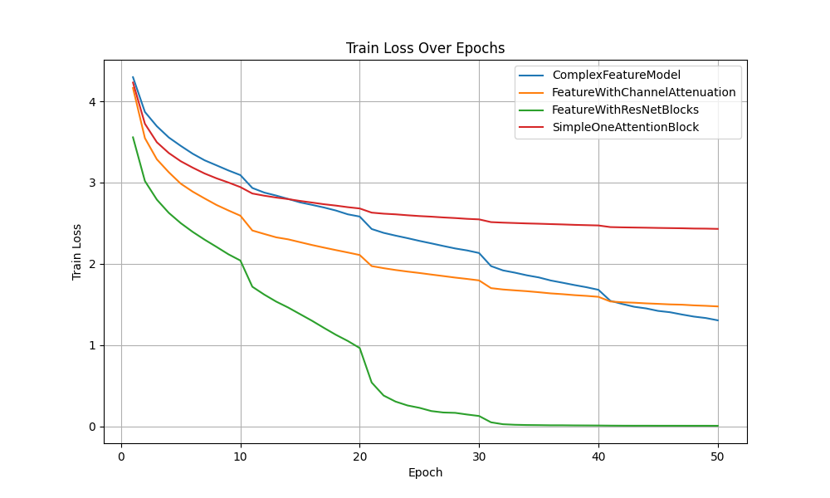
These results are disappointing, they consistently underperformed when compared to the simple ResNet models. The report believes that this is the issue with low resolution GAN systems as the researcher has found these to be very difficult. The results do show clear over fitting and instability however this is most likely due to the discriminator itself, this instability is shown in the best model created Feature with ResNet Blocks having a strange massive increase in test loss after 10 epochs.

Discussion
The starting ResNet model given in Lab7 was barebones but relatively effective given its size and complexity. The report decided to add many other additional aspects to it and found continuous improvement, however, the addition of complex systems such as multi-channel attenuation as well as cGAN discriminator did less effectively than just a hyper parameter tuned and optimised ResNet system. Maybe if these more complex systems were further hyper parameter tuned, they could outperform but from preliminary analysis the added complexity seems to tend towards overfitting and unstable training. This is very interesting and is a research lesson I hope to take into my further work
The report believes that there is much further research needed especially in the GAN portion. The report recommends further research into the idea of upscaling that I used extensively within the GAN systems to take a 32x32 image to a larger, blurrier, image to make GAN’s better and more stable at handling. The report really struggled on the GAN portion of the research, as not only are GANs generally difficult, the low res and already blurry dataset used in the research means that any generated image is hard to verify with the human eye. One way further research could address this is the use of pre processing such as edge detection and sharpening on the upscaled image, the paper tried this but couldn’t optimise it to not hit model collapse too quickly.
The ResNets are effective and accurate at image classification. The report found that they can be helped by using attenuation as well as Gan discriminators to a large degree but with small resolutions complex models tend to go towards overfitting and become increasingly low performing.
The research has also found that ResNets and its theoretical basis of skipping are effective at stabilising Synthetic data creation systems and protect it from model collapse as the report has found that base cGANs are prone to it collapse especially when handling low resolution data. The report did not include the difficulties with model collapse as graphing or displaying the problem was a research tangent on top of the research tangent that GAN already was.
Hyper parameter testing was included in both ResNet and ResNet GAN development and was found to be useful however done far tool early in the process. The report believes it should have completed hyper parameter testing as a final and optional addition to the best model discovered at the end of the report. The report believes that the hyperparameter testing was still useful and did lead to a more optimised outcome as all models going forward used those effective parameters but also knows that this is an area of improvement in the process of the research.

Conclusion
In conclusion, the research has found that advanced methods tend towards overfitting and when normalised with dropout or batch norm still under preforms compared to similar systems. An optimised and advanced ResNet system was found to outperform the more complex Attention and Discriminator feature extractor systems. This is disappointing as the goal of the research was to investigate potential benefits of using these more advanced systems. However, the knowledge that they tend towards overfitting on low resolution data and that low res GANs tend to fail make this reaserch useful non the less.
Attention and multi-channel attention was found to overfit but still preforms close comparatively to an optimised ResNet system. This is not satisfactory as they are far more complex to train and slower run meaning that comparative is close to failure.
The research spent lots of time trying to develop GAN data creation and discriminator systems on the low-resolution data and made great progress with the idea of upscaling. However, when these discriminator feature extractors were added to Resnet systems they under preformed compared to a optimized ResNet model. Further research on this topic is needed and interesting as there are many diverse forms of GAN and feature extractor systems.
Overall, the research completed its goal of investigating attention, GAN systems and optimised ResNet for the task of image recognition of the chosen dataset. The research result was that a optimised ResNet model out preformed the more complex models. This is most likely due to the low resolution of the original dataset. As a side result Resnet was found to be effective at stabilising GAN systems and outperformed basic GANs.

Appendix Tables

Hyperparamiter Test round 1 from 3.2.1
Test | best_epoch | train_loss | test_loss | test_acc | batch_size | learning_rate | num_blocks | c_hidden
0 | 21 | 1.366 | 2.02 | 0.467 | 32 | 0.01 | [3, 3, 3] | [16, 32, 64]
1 | 17 | 0.75 | 1.895 | 0.539 | 32 | 0.01 | [3, 3, 3] | [32, 64, 128]
2 | 25 | 1.539 | 1.865 | 0.49 | 32 | 0.01 | [2, 2, 2] | [16, 32, 64]
3 | 22 | 0.937 | 1.722 | 0.548 | 32 | 0.01 | [2, 2, 2] | [32, 64, 128]
4 | 25 | 2.877 | 2.894 | 0.274 | 32 | 0.001 | [3, 3, 3] | [16, 32, 64]
5 | 25 | 2.331 | 2.409 | 0.366 | 32 | 0.001 | [3, 3, 3] | [32, 64, 128]
6 | 25 | 3.014 | 3.049 | 0.24 | 32 | 0.001 | [2, 2, 2] | [16, 32, 64]
7 | 25 | 2.52 | 2.637 | 0.321 | 32 | 0.001 | [2, 2, 2] | [32, 64, 128]
8 | 23 | 1.403 | 2 | 0.472 | 64 | 0.01 | [3, 3, 3] | [16, 32, 64]
9 | 15 | 0.74 | 1.938 | 0.511 | 64 | 0.01 | [3, 3, 3] | [32, 64, 128]
10 | 25 | 1.519 | 1.891 | 0.494 | 64 | 0.01 | [2, 2, 2] | [16, 32, 64]
11 | 19 | 0.96 | 1.742 | 0.535 | 64 | 0.01 | [2, 2, 2] | [32, 64, 128]

Structure Test Results 1

Channel Attention structure Results

Attention Structure Results

ResNet Structure Results

Structure Test Results 2

Channel Attention Structure Results

Attention Structure Results

ResNet Structure Results

GAN Combination testing result
If I included every table in this section, it would triple or quadruple the size of the report. I have included the key skip generator and skip discriminator as a example

Gen ResNet Results
As the results are a full 50 epochs I will include the most important and most effective models results – the Feature with ResNet model.

Feature with ResNet Model

Simple Feature model

References
1. Krizhevsky, A. and Hinton, G. (2009) Learning Multiple Layers of Features from Tiny Images. Available at: https://paperswithcode.com/dataset/cifar-100 (Accessed: 14 December 2024).
2. He, K., Zhang, X., Ren, S. and Sun, J. (2016) 'Deep Residual Learning for Image Recognition', Proceedings of the IEEE Conference on Computer Vision and Pattern Recognition, pp. 770-778. Available at: https://ieeexplore.ieee.org/document/7780459 (Accessed: 14 December 2024).
3. Pascanu, R., Mikolov, T. and Bengio, Y. (2013) 'On the difficulty of training Recurrent Neural Networks', Proceedings of the 30th International Conference on Machine Learning, pp. 1310-1318. Available at: https://arxiv.org/abs/1211.5063 (Accessed: 14 December 2024).
4. Xue, T. and Hong, Y. (2021) 'IX-ResNet: fragmented multi-scale feature fusion for image classification', Multimedia Tools and Applications, 80(21), pp. 27855–27865. Available at: https://link.springer.com/article/10.1007/s11042-021-10893-1 (Accessed: 14 December 2024).
5. Wang, F., Jiang, M., Qian, C., et al. (2017) 'Residual Attention Network for Image Classification', arXiv preprint, arXiv:1704.06904. Available at: https://arxiv.org/abs/1704.06904 (Accessed: 16 December 2024).
6. Necas209 (2022) ResidualAttentionNetwork-PyTorch. Available at: https://github.com/Necas209/ResidualAttentionNetwork-PyTorch (Accessed: 16 December 2024).
7. Hu, J., Shen, L., Albanie, S., Sun, G. and Wu, E. (2017) 'Squeeze-and-Excitation Networks', arXiv preprint, arXiv:1709.01507. Available at: https://arxiv.org/abs/1709.01507 (Accessed: 16 December 2024).
8. jonnedtc (2018) Squeeze-Excitation-PyTorch. Available at: https://github.com/jonnedtc/Squeeze-Excitation-PyTorch (Accessed: 16 December 2024).
9. Wang M, Li H, Li F (2017). Generative Adversarial Network based on Resnet for Conditional Image Restoration. arXiv. Available at: https://arxiv.org/abs/1707.04881.
10. Elkholy, M. (2021) 'ResNet-GAN', GitHub Repository. Available at: https://github.com/Mohanned-Elkholy/ResNet-GAN (Accessed: 16 December 2024).
11. Akram, A. and Khan, N. (2021) 'US-GAN: On the importance of Ultimate Skip Connection for Facial Expression Synthesis', arXiv preprint arXiv:2112.13002. Available at: https://arxiv.org/abs/2112.13002 (Accessed: 16 December 2024).
12. Harvard Citation: Jam, J., Kendrick, C., Drouard, V., Walker, K., Hsu, G.S. and Yap, M.H. (2020) 'Symmetric Skip Connection Wasserstein GAN for High-Resolution Facial Image Inpainting', arXiv preprint arXiv:2001.03725. Available at: https://arxiv.org/abs/2001.03725 (Accessed: 16 December 2024).
13. Chow KVC, O'Leary C, Paxton-Hall F, Lambie D, O'Byrne K. Enhanced Image Super Resolution Using ResNet Generative Adversarial Network. Traitement du Signal. 2024;41(4):433-440. doi:10.18280/ts.410432.

